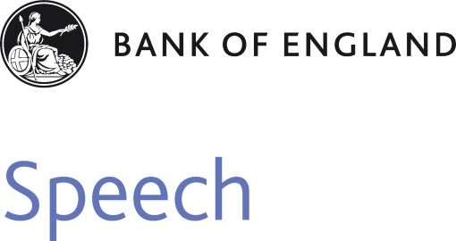

# Remarks given by

Mark Carney, Governor of the Bank of England

At the Bank of England 18 December 2013

Ensuring public trust and confidence in money is at the heart of what central banks do. Money can only play its invaluable role in our economy if that trust and confidence is maintained. That motivates the Bank of England’s core objectives of price stability, so that people can be confident of the value of their money over time, and financial stability so that they will be able to access and use money when they want to.

It is also why we place such importance on maintaining confidence in our banknotes, the most tangible form of money. Our job is to ensure that the banknotes people use are high quality and genuine. We also recognise that banknotes are an important national symbol and a source of national pride.

Our banknotes must therefore be secure from counterfeiting, resistant to damage, and designed in a way that inspires broad public support and fosters legitimacy. We are continually working to ensure that our notes meet those requirements.

That is why I am pleased to announce today that the next Bank of England notes will be printed on polymer, rather than cotton paper. The first polymer note will be the £5 note featuring Sir Winston Churchill, and will be issued in 2016. It will be followed around a year later by a polymer £10 note featuring Jane Austen. The decision to move to polymer for these notes follows a three-year review and a broad public consultation exercise. Our research has shown a compelling case for polymer notes.

Polymer notes bring three main benefits:

* They stay **cleaner** than paper banknotes because they are resistant to dirt and moisture;
* They are more **secure** because they incorporate advanced security features that make them difficult to counterfeit;
* And they are more **durable**, lasting at least 2½ times as long as paper banknotes, ensuring that notes in circulation remain of high quality. Because replacements are needed less often they are both **cheaper** over time, and more **environmentally friendly**.

These advantages mean that a switch to polymer is a natural step in the evolution of banknote design. But you don’t have to take our word for it. Nearly 13000 people have told us what they thought, in surveys and at over 40 events up and down the UK, and 87% – the vast majority – were in favour of polymer notes, especially once they had a chance to see and handle prototype notes.

After that public consultation, we’re confident that the switch to polymer will have broad public support.

For those who might be concerned about the change, let me reassure you that the new polymer notes will retain the familiar look of Bank of England banknotes, including of course the portrait of Her Majesty the Queen, as well as depictions of historical characters of national significance. That continuity of design helps explain why people who have had a chance to handle specimen notes were even more likely to view polymer favourably.

The depiction of historical characters will remain an integral feature of our banknotes, providing an opportunity to celebrate individuals that have shaped the United Kingdom. In order to ensure public confidence in banknotes, it is essential that the choice of characters commands broad public respect and legitimacy.

That is why in July, at the same time as announcing that Jane Austen would feature on the new £10 note, I promised that we would review the way in which the characters featured on banknotes are selected. Today we are announcing a new set of principles to guide the choice of characters and a new process to ensure that those principles are, and are seen to be, followed.

The new principles for character selection state clearly and positively the Bank’s aims in using historic characters on our notes. They put diversity and inclusivity at the heart of the selection criteria. And they make clear our intention to portray a diverse range of characters over time, with each new decision taking into account previous choices.

The new process will be open, transparent and inclusive. There will be greater input from the public and from external experts in the form of a new Advisory Committee with a majority of independent members. That body will recommend a broad theme – for example scientific achievement – before the public are invited to nominate characters within that theme. The Advisory Committee, with input from public focus groups, will narrow down the field to a final shortlist of characters and the Governor will make the final choice from that shortlist.

These changes will ensure that the characters on our banknotes are fully representative of the history and diversity of this great nation, while having the necessary public respect and legitimacy.

Our polymer notes will combine the best of progress and tradition. They will be more secure from counterfeiting and more resistant to damage while celebrating the history and tradition that is important both to the Bank and the nation as a whole.

By consulting widely on the switch to polymer, and by putting in place a new process for selecting banknote characters with much more public input, we have reinforced the commitment to openness and transparency which lies at the heart of the Bank of England’s commitment to accountability.

Together, these announcements ensure that our banknotes will remain both a national symbol and a source of national pride.